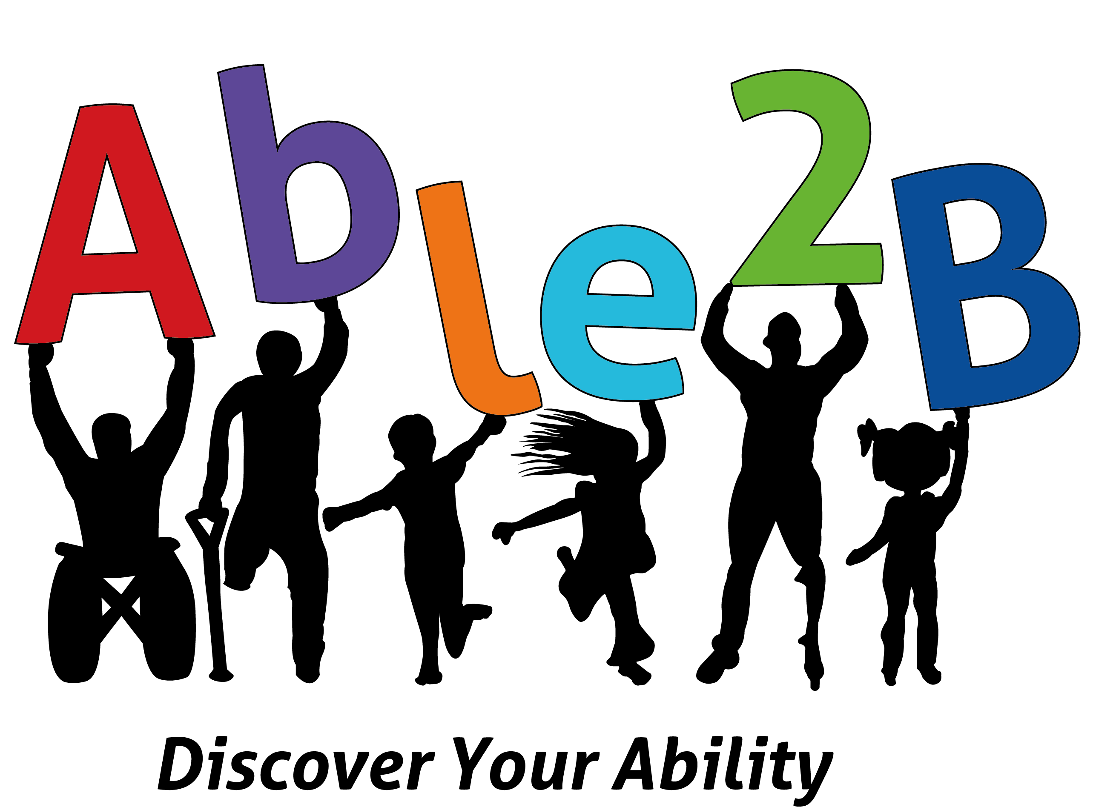

Safeguarding Procedures and
Child Protection Policy

Safeguarding Procedures and
Child Protection Policy
Safeguarding and Child Protection Policy and Procedures for Able2B

Able2B is a community interest company set up to develop services that help improve function for children and adults with a disability.
Able2B aims to provide an opportunity for members to participate and enhance their health and wellbeing through their organised sessions. Able2B will always endeavour to provide for the health, welfare and well-being of its members and associates.
Able2B are committed to safeguarding and promoting the welfare of all children.
Aim
The purpose of Able2B’s safeguarding policy is to ensure every child at our organisation is safe and protected from harm.
This means we will always work to:
• protect children from maltreatment
• prevent impairment of children’s health or development
• ensure that children are growing up in circumstances consistent with the
provision of safe and effective care
• act to enable all children to have the best outcomes

This policy will give clear direction to staff, volunteers, visitors and parents about the expected behaviour and our legal responsibility to safeguard and promote the welfare of all children at Able2B.
Introduction
Able2B fully recognises the contribution it can make to protecting children from harm and supporting and promoting the welfare of all children. The elements of our policy are prevention, protection and support.
Our policy applies to all children, volunteers, visitors and staff.
A child is someone under the age of 18 years old.
Our Ethos
Able2B will establish and maintain an ethos where our children feel secure, are respected, feel valued, are listened to and are safe. Children will be able to talk freely to any member of staff or volunteer at Able2B if they are worried or concerned about something.
All staff and volunteers, either through training or induction, know how to recognise a disclosure from a child and will know how to manage this. We will not make promises to any child and we will not keep secrets. Every child will know what the adult will do with whatever they have been told.

At all times we will act in partnership with parents, carers.
General Procedures
When new staff or volunteers join our organisation, they will be informed of the safeguarding arrangements in place. They will be given a copy of Able2B's safeguarding policy and told who our Designated Child Safeguarding Officer is. They will also be shown the recording format, given information on how to complete it and who to pass it to.
Every new member of staff or volunteer will have an induction period of 3 months that will include essential safeguarding information. This programme will include safeguarding training through the Safer Programme, or equivalent, relating to signs and symptoms of abuse, how to manage a disclosure from a child, how to record and issues of confidentiality. The induction will also remind staff and volunteers of their responsibility to safeguard all children and the remit of the role of the Designated Child Safeguarding Officer.
All staff and volunteers will be asked to read this policy yearly after it has been reviewed and updated if necessary. They will sign to say they have read and understood the policy.
We will display the reporting and referral flowchart when our organisation is operating.
All regular visitors and volunteers to our organisation will be told where our policy is kept, they will be given a set of safeguarding procedures, they will be told who our Designated Child Safeguarding Officer and alternate staff members are and what the recording and reporting system is.
All parents and carers will be asked to sign a distribution list confirming they have seen and read our safeguarding policy. Parents and carers will be informed of our legal duty to assist our colleagues in other agencies with child protection enquiries and what happens should we have cause to make a referral to Children’s Advice and Duty Service.
Parents will sign a consent form at the start of their child’s involvement with the organisation, which includes any vital health or otherwise notable information. It also requests permission for photographs to be taken for promotional purposes only. This will also include a statement making parents/carers aware that by signing they consent to us sharing information with the relevant authorities if we have concerns about the welfare of their child/children, but that we would always seek to discuss safeguarding concerns with a parent/carer first unless to do so would place a child at risk or undermine a criminal investigation.
Training
Full-time staff members will undertake appropriate safeguarding training through the NSCP Safer Programme, or through other safeguarding organisations, every three years.
Our volunteers are school students undergoing placements or work experiencee and therefore are only with our organisation for a short period of time, they are never left alone with any children and are always supervised by staff.
For contracted or part-time staff, proof of mandatory training through their associated job roles (e.g trainee physiotherapist) will need to be provided. If staff member does not have proof of validated training or is a new member of staff, they will need to complete the safer programme training within 3 months of commencing the post and/or prior to undertaking unsupervised work.
We actively encourage all our staff to keep up to date with the most recent local and national safeguarding advice and guidance. This can be accessed via www.norfolklscb.org
The Designated Officer should be used as a first point of contact for concerns and queries regarding any safeguarding concern in our organisation.
Safer Staff and Volunteers
All adults who meet our children have a duty of care to safeguard and promote their welfare. There is a legal duty placed upon us to ensure that all adults who work with or on behalf of our children are competent, confident and safe to do so.
We ensure we adhere to the principles of safer recruitment as per our policy and also the guidance from Norfolk Safeguarding Children Partnership.
We ensure that we:
• Carefully consider the job description and person specification
• Circulate all vacancies widely
• Prepare an information pack
• Ask for a written application form
• Define our selection criteria
• Ask for a written declaration with regards to criminal convictions, spent or otherwise
• Ask for identification
• Ask for originals of any qualifications
• Conduct interviews with at least two people present
• Ask for at least two references, including the last employer
• Gain enhanced DBS checks where current Government guidance requires us to
• Organise a comprehensive induction period which includes familiarisation with our safeguarding policies, procedures and safeguarding training through the Safer Programme.

Our aim is to provide a safe and supportive environment which secures the wellbeing and very best outcomes for our children. We do recognise that sometimes the behaviour of adults may lead to an allegation of abuse being made.
Allegations sometimes arise from a differing understanding of the same event, but when they occur, they are distressing and difficult for all concerned. We also recognise that many allegations are genuine and there are some adults who deliberately seek to harm or abuse children.
We will take all possible steps to safeguard our children and to ensure that the adults in our organisation are safe to work with our children. We will always ensure that the Norfolk Safeguarding Children Partnership procedures are followed.
All adults who come into contact with children will be made aware of the steps that will be taken if an allegation is made. We will seek appropriate advice from the Local Authority Designated Officer (LADO) within 24 hours of a concern or allegation being made. The LADO can be contacted via the referral/consultation forms under 'how to make a referral' at www.norfolklscb.org.
Staff will not investigate these matters. We will seek and work with the advice that is provided. Should an allegation be made against the Designated Child Safeguarding Officer or Deputy, this will be reported by the staff member or volunteer raising the concern directly to the LADO.
There are sensible steps that every adult should take in their daily professional conduct with children. These can be found in the NSCP Safer Programme Safer Working Practice (this guidance is on the NSCP website).
Records and Confidentiality
If we are concerned about the welfare or safety of any child in our organisation, we will record our concerns immediately on the agreed report form and give this to the Designated Child Safeguarding Officer.
Any information recorded will be kept in a separate named file, in a secure, locked cabinet in the Able2B office and not with the child’s file. These files will be the responsibility of the Designated Child Safeguarding Officer and information will only be shared within the organisation on a need-to-know basis for the protection of the child.
Any safeguarding information will be kept in the file and will be added to. Copies of referrals will be stored in the file.
All information is confidential, however if there is a safeguarding or child protection concern about a child, then information can be shared with other agencies, namely the Police or Children’s Services.
Reports of a concern to the Designated Child Safeguarding Officer must be made in writing and signed and dated by the person with the concern.
Roles and Responsibilities
Our Designated Child Safeguarding Officer will liaise with Children’s Advice and Duty Service and other agencies where necessary and make referrals to Children’s Advice and Duty Service using the procedure below.
Any concern for a child’s safety or welfare will be recorded in writing and given to the Designated Child Safeguarding Officer who will be responsible for ensuring that all staff members and volunteers are aware of our policy and the procedure they need to follow.
The Designated Child Safeguarding Officer will ensure that all staff and volunteers have received appropriate child protection information during induction and have been trained by the Safer Programme.
The Designated Child Safeguarding Officer will ensure that our safeguarding policy is in place and is reviewed annually. The content of our policy has been written following consultation with the Safer Programme.

At all times the Designated Child Safeguarding Officer will ensure that safer recruitment practices are followed.
Our organisation undertakes to remedy without delay any weakness regarding our safeguarding arrangements that are brought to their attention.
Procedures for Handling Disclosures
A child may decide to disclose information that may indicate they are suffering from abuse or neglect. A child chooses to speak to an adult because they feel that they will listen and that they can trust them. The adult needs to listen to what the child has to say and be very careful not to ‘lead’ the child or influence in any way what they say.
It is important that the adult remembers to:
• Stay calm
• Listen and be supportive
• Not ask any leading questions, interrogate the child, or put ideas in the child’s head, or jump to conclusions
• Not stop or interrupt a child who is recalling significant events
• Never promise the child confidentiality – it must be explained that information will need be to be passed on to help keep them safe
• Avoid criticising the alleged perpetrator
• Tell the child what must be done next (the safeguarding process must be followed)
• Record what was said immediately as close to what was said as possible. Also record what was happening immediately before the child disclosed. Be sure to sign and date the record in ink.
• Contact the designated person immediately
• Seek support

We are clear that the Local Authority and Police must lead any investigation into any allegation regarding safeguarding.
If we have a concern about a child or children, we will telephone the Children’s Advice and Duty Service (CADS) on 0344 800 8021 immediately. We will be put through to a Social Worker who will take all the relevant details. We will make sure we are prepared with full details of the child and family, plus what our concerns are, details of any support we have provided to the child/family and what we would like to happen. We will ensure we gain consent from the parent/carer unless to do so would place the child at further risk of harm or undermine a criminal investigation. If we have not sought consent from the parent/carer we will inform the CADS worker of this and the reason for this.
The CADS worker will agree a way forward with us and keep us informed. They will send us a written record of our conversation within 5 working days. The outcomes could include a full referral to the Multi Agency Safeguarding Hub (MASH) for further investigation, the Police, or for work with Early Help. We will not investigate and will be led by the Local Authority and/or the Police.
We will make careful records of all conversations, in ink, including the dates and times of who we spoke to, the information shared, and the action agreed. We do not need to send a written referral.
Full details on this process can be found at www.norfolklscb.org under ‘How to Raise a Concern’.
We understand if we are unhappy about a decision made by CADS or MASH, we can use the Resolving Professional Disagreements policy on www.norfolklscb.org and contact the Safer Programme for more advice on this process
Working Together 2018
What is abuse and neglect?
A form of maltreatment of a child. Somebody may abuse or neglect a child by inflicting harm, or by failing to act to prevent harm. Children may be abused in a family or in an institutional or community setting by those known to them or, more rarely, by others (e.g. via the internet). They may be abused by an adult or adults, or another child or children.
Physical abuse
A form of abuse which may involve hitting, shaking, throwing, poisoning, burning or scalding, drowning, suffocating or otherwise causing physical harm to a child. Physical harm may also be caused when a parent or carer fabricates the symptoms of, or deliberately induces, illness in a child.
Emotional abuse
The persistent emotional maltreatment of a child such as to cause severe and persistent adverse effects on the child’s emotional development. It may involve conveying to a child that they are worthless or unloved, inadequate, or valued only insofar as they meet the needs of another person. It may include not giving the child opportunities to express their views, deliberately silencing them or ‘making fun’ of what they say or how they communicate. It may feature age or developmentally inappropriate expectations being imposed on children. These may include interactions that are beyond a child’s developmental capability, as well as overprotection and limitation of exploration and learning, or preventing the child participating in normal social interaction. It may involve seeing or hearing the ill-treatment of another. It may involve serious bullying (including cyber bullying), causing children frequently to feel frightened or in danger, or the exploitation or corruption of children. Some level of emotional abuse is involved in all types of maltreatment of a child, though it may occur alone.
Sexual abuse
Involves forcing or enticing a child or young person to take part in sexual activities, not necessarily involving a high level of violence, whether or not the child is aware of what is happening. The activities may involve physical contact, including assault by penetration (for example, rape or oral sex) or non-penetrative acts such as masturbation, kissing, rubbing and touching outside of clothing. They may also include non-contact activities, such as involving children in looking at, or in the production of, sexual images, watching sexual activities, encouraging children to behave in sexually inappropriate ways, or grooming a child in preparation for abuse. Sexual abuse can take place online, and technology can be used to facilitate offline abuse. Sexual abuse Is not solely perpetrated by adult males. Women can also commit acts of sexual abuse, as can other children.
Neglect
The persistent failure to meet a child’s basic physical and/or psychological needs, likely to result in the serious impairment of the child’s health or development. Neglect may occur during pregnancy as a result of maternal substance abuse.
Once a child is born, neglect may involve a parent or carer failing to:
• provide adequate food, clothing and shelter (including exclusion from home or abandonment)
• protect a child from physical and emotional harm or danger
• ensure adequate supervision (including the use of inadequate caregivers)
• ensure access to appropriate medical care or treatment.

It may also include neglect of, or unresponsiveness to, a child’s basic emotional needs.
Safeguarding and promoting the welfare of children
Defined for the purposes of this guidance as:
• protecting children from maltreatment
• preventing impairment of children’s health or development
• ensuring that children are growing up in circumstances consistent with the provision of safe and effective care
• taking action to enable all children to have the best outcomes.

Child protection
Part of safeguarding and promoting welfare. This refers to the activity that is undertaken to protect specific children who are suffering, or are likely to suffer, significant harm.
Relevant Guidance and Legislation
• Working Together 2018
• What to do if You’re Worried a Child is Being Abused 2015
• Children Act 2004
• Children Act 1989
• Framework for the Assessment of Children in Need and their Families
Other Relevant Policies
To underpin the values and ethos of our organisation and our intent to ensure our children/young people are appropriately safeguarded the following policies are also included:
Safer Recruitment
Bullying
Code of Conduct
Confidentiality
Whistle Blowing
Complaints
Useful Contacts
Children’s Services 24 hours 0344 800 8020
Norfolk Police 101
In an emergency 999
Norfolk Safeguarding Children Partnership www.norfolklscb.org
Safer Programme 01603 228966

Code of conduct for directors, coaches and volunteers for Able2B
Able2 endeavours to teach and support members not only during classes and sessions but also in their daily lives. To do this, we need to be committed to modelling the types of behaviour and qualities we expect.
I will
• Treat all children and young people with respect and dignity and reinforce the concepts of responsibility, trust, competence, honesty, fairness and sportsmanship and promote a culturally tolerant environment
• Ensure that their welfare and safety is always paramount
• Ensure accessibility for all to participate in activities
• Always act in a professional way and not accept bullying, swearing or other disruptive behaviour
• Liaise openly with parents and carers
• Adhere to Child Safeguarding Policies and Procedures for Able2B always
• Listen to, and act upon, any disclosures, allegations or concerns about the welfare of children
• Attend Child Safeguarding training as required
• Make sure we all have fun
Name: Ella Thaxton
Signed:
Date: 05/09/2022

