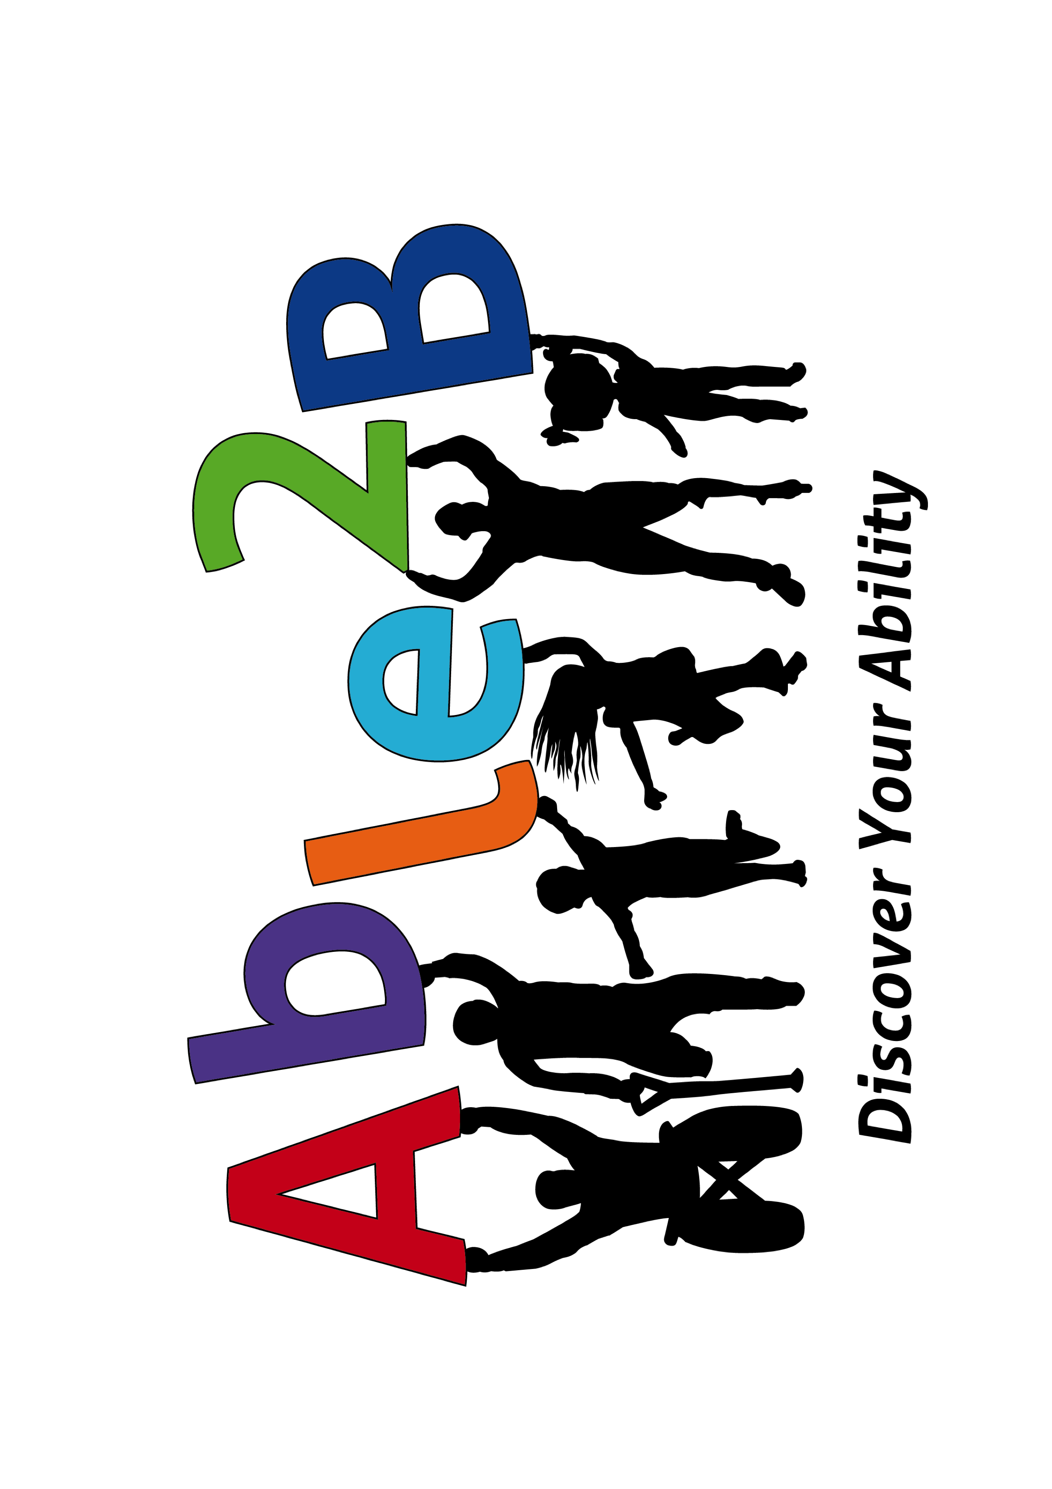
Able2B
Summary of
Procedures
2023

Contents

1.0 Introduction & Welcome to Able2B ............................................................................................. 3
1.1 Statement of Purpose and Values ................................................................................................. 4

2.0 Code of Conduct .................................................................................................................................... 5
2.1 Administrators Code of Conduct ................................................................................................... 5
2.2 Coaches Code of Conduct ..................................................................................................................6
2.3 Members Code of Conduct ............................................................................................................... 7
2.4 Members, Spectators and Parent/Guardians Code of Conduct ........................................7
2.5 Breaches of the Codes of Conduct ............................................................................................... 8

3.0 Able2B Policies and Procedures .................................................................................................. 9
3.1 Grievance Procedure ........................................................................................................................ 9
3.2 Equal Opportunity & Tolerance Policy ..................................................................................... 10
3.3 Duty of Care .......................................................................................................................................... 10
3.4 Medical Information ......................................................................................................................... 10
3.5 Membership/Subscription Fees .................................................................................................. 10
3.6 Social Media .......................................................................................................................................... 11
3.7 Drugs and Alcohol .............................................................................................................................. 11
3.8 First Aid & Health and Safety Requirements for Players ...................................................11

4.0 Incident Reporting ............................................................................................................................ 11
APPENDIX A – first aid/medically qualified staff......................................................................... 12
APPENDIX B - trainers/directors accreditations........................................................................ 12
APPENDIX C - directors.............................................................................................................................12

Able2B requires this Handbook and Procedure Document
to be utilised by members and volunteers using its services.

- Introduction & Welcome to Able2B

If you are a new member then welcome and thank you for your support.
If you are a returning member, welcome back!

Please read through the enclosed policies and guidelines to familiarize yourself on how we operate and behave as a whole Club. The procedures and information contained within have been designed to assist us in operating, with the continuity and spirit in which Able2B was founded.

We pride ourselves on being a family and all inclusive service. Being a member of the Able2B isn’t just for the individual, it’s also for the families and friends.
Part of the enjoyment felt by those involved is seeing their parents, grandparents and friends taking an active role in their sport.

We are a Club administered and run partly by volunteers so it is vital that everyone participates to spread the load evenly across all members, whether by helping at sessions, at training or at fundraising events. Without these contributions, we
would not be able to function.

We have created a Code of Conduct for each group of people participating within
Able2B and it is vital that all understand and comply with these policies.

Whether coaching, volunteering or supporting, everyone connected to Able2B
represents us and their behaviour reflects our values.

Please familiarise yourself with these procedures and other information and bear
them in mind when supporting to make the experience fun for all involved.

Once again, thank you for being involved with us as we strive to ensure every member enjoys what we have to offer.

Rachael Hutchinson
Director Able2B

1.1 Statement of Purpose and Values

Able2B aims to provide an opportunity for members to participate and enhance their health and wellbeing through their organised sessions. Able2B will, at all times, endeavour to provide for the health, welfare and well-being of its members and associates. This aim will be achieved by promoting and developing the following values and objectives:

- Sense of social and company values
- An environment to nurture the physical and mental development of our members;
- Respect for other members and their supporters;
- Equal opportunities for everyone;
- A responsible environment in relation to alcohol.

They will be realised by providing as far as reasonable:
- Competent personal trainers and assistants;
- Adequate facilities, amenities and equipment;
- Supervised social functions encouraging family participation;
- Regular communication and consultation with members and parents;
- Active leadership and management of Able2B.

All members, coaches, parents, supporters and company members have a responsibility at all times, when representing Able2B to conduct themselves in an appropriate manner consistent with these values and Codes of Conduct.

2.0 Club Code of Conduct

Able2B endeavours to teach and support members not only during classes and sessions but also in their daily lives. To do this we need to be committed to modeling the types of behaviour and qualities we expect.

Members, spectators and parents should ensure behaviour is consistent with the principles of Able2B. Therefore:

- Swearing or abuse by trainers, members or spectators is not permissible
at any time.
- Aggressive behaviour and abuse toward other members, coaches, parents or spectators is unacceptable.
- Consumption of alcohol is strongly discouraged while under age sport is
being conducted.

2.1 Administrators Code of Conduct

The Administrators Code of Conduct is a positive document for all Able2B
Administrators. It affirms their responsibility for the correct and appropriate
management of Able2B and its coaches, members, parents and
supporters. Administrators are responsible for reinforcing the concepts of
responsibility, trust, competence, respect, safety, honesty, fairness,
professionalism, equity and sportsmanship within Able2B to promote a positive
image.

Integrity
- Ensure you are aware of your obligations to provide a child safe environment.
This includes risk management, child safe policy, appropriate screening of
staff/volunteers and mandatory notification obligations of certain people in the
organisation.
- Ensure accessibility for all to participate.
- Create pathways for people, particularly new and young people, to participate
in sessions - give them “a say “on decisions that affect them, provide
leadership opportunities and most importantly listen to them.
- Ensure that the types of programs, rules, equipment, length of training schedules are modified to suit the age, ability and maturity level of all players.
- Ensure quality supervision and instruction for all players.
- Ensure volunteers are adequately trained.
- Direct coaches to highlight appropriate behaviour and skill development.
- Remember, you set an example - your behaviour and comments should be
positive and supportive.
- Implement policy and practices, and lead by example, in relation to
responsible use of alcohol and in relation to recreational and performance
enhancing drugs.
- Adopt and implement relevant sport safety policies and practices.

Respect
- Promote a culturally tolerant environment.
- Respect the rights, dignity and worth of all participants - regardless of their
gender, ability, cultural background or religion.

2.2 Coaches Code of Conduct

The Coach’s Code of Conduct is a positive document for all coaches. It affirms a
coach’s support for the concepts of responsibility, trust, competence, respect,
safety, honesty, professionalism, equity and sportsmanship.

Safety and Health of Participants
- Place the safety and welfare of the participants above all else.
- Be aware of and support sport’s injury management plans and return to
sport guidelines.

Coaching excellence
- Help each person to reach their potential. Respect the goals of each person and encourage them with positive and constructive feedback.
- Encourage and support opportunities for people to learn appropriate behaviours and skills.
- Support opportunities for participation in all aspects of the classes.
- Treat each participant as an individual.
- Obtain appropriate qualifications and keep up-to-date with the latest coaching
practices and the principles of growth and development of participants.
- Display responsible behavior in relation to alcohol and other drugs.
Integrity
- Act with integrity and objectivity, and accept responsibility for your decisions
and actions.
- Ensure your decisions and actions contribute to a harassment-free
environment.
• Ensure you are aware of Able2B’s safe-guarding policy. Wherever practical,
avoid unaccompanied and unobserved one-on-one activity (when in a
supervisory capacity or where a power imbalance exists) with people under
the age of 18. Ensure you are aware of your mandated responsibility to
report suspicion of child abuse and neglect.
- Ensure that any physical contact with another person is appropriate to the
situation and necessary for the person's skill development.
- Be honest and do not allow your qualifications or coaching experience to be
mis-represented.
- Never advocate or condone the use of illicit drugs or other banned
performance enhancing substances or methods.

Respect
- Respect the rights and worth of every person, regardless of their age, race,
gender, ability, cultural background, sexuality or religion.
- Do not tolerate abusive, bullying or threatening behaviour.

2.3 Members Code of Conduct

The Members Code of Conduct is a positive document for all members. It affirms a
member’s support for the concepts of responsibility, trust, competence, respect,
safety, honesty, professionalism, equity and sportsmanship.

Honour the sport
- Act within the rules and spirit of your session.
- Respect the decisions of coaches and administrators.
- Show respect and courtesy to all involved with the sessions.
- Display responsible behaviour in relation to alcohol and other drugs.

Integrity
- Show respect to and acknowledge other members.
- Cooperate with your coach.
- Participate for your own enjoyment and benefit - not just to please parents,
coaches or other people.

Respect
- Respect the rights, dignity and worth of all participants - regardless of their
gender, ability, cultural background or religion.
- Do not expect or accept “special” favours from a coach or person involved in
Able2B management.
- Speak to an adult or someone you trust if you have an issue, feel unsafe or
are concerned about someone else.

2.4 Members, Spectators and Parent/Guardians Code of Conduct

The Members, Spectator and Parent/Guardians Code of Conduct is a positive
document for all spectators and families of players. It affirms their support for
Able2B and/or child and other members. It aims to instill the concepts of
responsibility, trust, competence, respect, safety, honesty, professionalism,
equity and sportsmanship to promote a good image within Able2B.

Integrity
• Remember that members participate for their own enjoyment - not
yours.
- Ensure you are aware and follow the correct processes to follow if you have
an issue or complaint – do not perpetuate issues with gossip or general
criticism. If you disagree with a coach, raise the issue through the
appropriate channel rather than question the coach or trainer’s judgement
and honesty in public. Refer concerns about coaches or trainers through the Directors.
- Never ridicule or yell at a member for making a mistake.
• Show appreciation for trainers - remember they are often volunteers.
- Applaud good performance and efforts from all individuals and members involved.

Remember that people learn best from example.
- Congratulate all participants regardless of their achievement level.
- Support all efforts to remove verbal and physical abuse regardless of whether it is by spectators, coaches, or members.
- Support all policies and practices of Able2B. This includes responsible alcohol and drug use and support of safe-guarding strategies.

Respect
- Respect the rights, dignity and worth of every person, regardless of their
gender, ability, cultural background or religion.
• Recognise the value and importance of volunteer coaches. They give of their
time and resources to provide recreational activities for members and
deserve your support.

2.5 Breaches of the Codes of Conduct

Able2B views breaches of the Codes of Conduct seriously and will take the following actions where a breach occurs:

1. Club directors or trainers will speak to anyone who is in breach of one of the Codes of Conduct to modify their behaviour. If the person does not modify their behaviour, the director or trainer may elect to take one or more of the following actions:
- Ask the offender to remove themselves from the immediate area until they have settled down.
- Ask the offending person to leave the premises.
- Refer the player, parent or spectator to the Directors for further action.

2. If a spectator or parent has an issue with the trainers, they should refer the
issue to either the trainer or a director.
3. Please do not abuse, either verbally or physically any members, trainers or volunteers in public, use the contacts listed below if you have an issue that needs to be addressed.

- Able2B Club Policies and Procedures

At the very core of Able2B is the maintenance of equity of opportunity to participate in
sport. This has a profound impact on the self-esteem of the members, the
development of their skills, fitness and understanding. To this end the following compulsory policies must be adopted by all representing Able2B.

The current policies of Able2B include:
• Risk Management Policy
• Equal Opportunity and Tolerance Policy
• Anti-Harassment and Sexual Harassment Policy
• Volunteer Management Policy
• Disability Discrimination Policy
• Refund, Fee Waiver Policy
• Safe-guarding Policy.

Details of some of these policies can be found throughout this document.

3.1 Grievance Procedure

At times, people may have issues that concern them and/or their child or another
Member or trainer. Able2B requires that all issues are resolved to the satisfaction of all parties in a timely fashion.
All members have a responsibility to participate in reasonable actions to resolve
issues. In the event of a grievance being raised by someone in regards to these
areas or other area of concern, the procedures below detail the steps to expedite
issue resolution.

PROCEDURE
1. Any person wishing to raise an issue should contact the following people in the
first instance:
a. Sport related – Trainer or coach
b. Coaching related – Coach
c. General issue-Director (APPENDIX C)
2. Where the initial parties cannot resolve the issue, the Directors of Able2B. (APPENDIX C)

3. The trainer, coach or volunteer at any time call on the directors for assistance. Any individual or session related issue reported to the Directors, where the trainer, coach or volunteer has not been given the initial opportunity to resolve any such issue, will be referred back to fore-mentioned person. All persons must take reasonable actions
to avoid situations that could cause serious injury or harm to health of members,
trainers or the public. If any hazard is identified the Directors are to be
informed as soon as possible.

3.2 Equal Opportunity & Tolerance Policy

In summary of this Policy, Able2B is committed to an environment which promotes tolerance by prohibiting certain conduct. An outline of what is considered to be vilification and/or discrimination is contained below:
- No member, spectator or team official shall behave in a way that humiliates,
intimidates, ridicules, incites, threatens, vilifies or insults another person
because of that person's race, gender, marital/parental status, physical or
intellectual impairment, same sex preference, age or political affiliation or
beliefs.
- To vilify someone is to speak ill of them.
- The behaviour may be in the form of name-calling, general abusive language
or talking about someone behind their back.

3.3 Duty of Care

- Coaches are responsible for the supervision all members involved in their sessions.
- Coaches are not responsible for the supervision of any siblings of members at training that are not involved in that session.
- Coaches have the right to cancel training or matches due to unforeseen circumstances
- It is the Coaches responsibility to be present at every training session. Where
this is not possible, another Coach or Director may step in. No training session may take place unless a suitable replacement is sourced with the appropriate certifications, ie Police Check, where possible.
- If an injury occurs during a training session or match, the trainer, director or designated Club Official has a duty of care to remain with the member until a parent or appropriate adult can be contacted and arrange for collection of the injured member.

3.4 Medical Information

- Coaches are to ensure that all medical forms are completed by every member on joining and kept on file at all times. It is your responsibility as the coach to ensure all forms are collected and you become familiar with any medical needs for the members of your class.
- Volunteers are required to fill out a medical form and this is contained in the medical file.
- If a player has “anaphylaxis”or “Asthma”, a management plan needs to be provided by the parent of the member.
- In the event of an injury, Coaches are to fill out an accident report (available in
the medical file) and submit to the Directors within 7 days of the incident.

3.5 Able2B Membership/Subscription Fees

All member subscriptions/fees are to be paid in full by or at the start of a session,
unless otherwise stipulated by the trainer or director. Subscriptions
can be paid to trainer at any session, or at a suitably arranged time.
Please also refer to the Clubs’ Refund, Fee Waiver and Hardship Policy which can be found in the Sports Club Policy Manual.

3.6 Social Media

Respect to the individual coaches, volunteers and members and anyone associated with Able2B must be displayed at all times when using social media such as Facebook, Twitter and the like, or if you are interviewed or asked for comment. When publishing data for public viewing, no individual names or identities shall be used without prior consent.
If in doubt please check with a trainer or Director before publishing or giving information to any public source.

3.7 Drugs and Alcohol

Able2B supports a zero tolerance to drugs and encourages the responsible
consumption of alcohol. Able2B enforces a strict no-alcohol environment within its premises.

3.8 First Aid & Health and Safety Requirements for Members

It is a requirement that all Trainers are trained to REPP standard for fitness training. A person or persons will be present at sessions that has basic first aid training. (APPENDIX A)
Able2B is responsible for maintaining the first aid kits to the required standard.
Any extra first aid/medical needs of an individual child are to be passed on to the Trainer with instructions.

- Incident Reporting

In the event of an incident occurring during a session the trainer is required to complete an Incident Report (Appendix D). The Directors should be advised ASAP and the completed forms should be passed on as soon as is practicable. It is at Able2B’s discretion as to how they choose to deal with the incident, ensuring all policies are adhered to.

APPENDIX A-
CURRENT FIRST AID CERTIFICATE HOLDERS/MEDICALLY TRAINED STAFF:

- Rachael Hutchinson Basic Life Support Adults and Children / Medical Doctor
- Scott Rowbotham Basic Life Support

APPENDIX B
COACH/TRAINER/DIRECTOR ACCREDITATION INFORMATION

Rachael Hutchinson MB ChB MD FRCS (Tr. & Orth.)
Qualified Doctor/Consultant Surgeon
Safe-guarding level 3
First aid/resuscitation trained
Equal Opportunities trained
Information Governance
DBS

Scott Rowbotham BSc Physiotherapist MCSP
BSc Sports Rehabilitation
Basic Life support
DBS
Safeguarding adults and children Level 2
Data protection, Prevent, Information Governance

APPENDIX C-
DIRECTORS INFORMATION

Rachael Hutchinson – Director
Jon Thaxton – Director
Scott Rowbotham – Director
Jill Lawson – Director

APPENDIX D
INCIDENT REPORT FORM

